*به نام خدا*



**نام و نام خانوادگی :**

حامد باغستانی

**شماره دانشجویی :**

40116143

**سیستم های کنترل خطی**

Q1)

**Matlab Code :**

%Soal 1 Tamrin 2

%Hamed Baghestani (40116143)

clc;

clear all;

close all;

k=1.58;

Wn=11.348;

zeta=0.25;

s=tf('s');

figure('Name','Soal1','NumberTitle','off');

% open Loop transfer function

subplot(2,1,1);

Ls= (k*Wn^2)/(s^2+2*zeta*Wn*s+(1-k)*Wn^2);

step(Ls);

title('open Loop transfer function');

%closed loop transfer function

subplot(2,1,2);

Ts= (k*Wn^2)/(s^2+2*zeta*Wn*s+Wn^2);

step(Ts);

title('closed Loop transfer function');

**Output or Plot :**

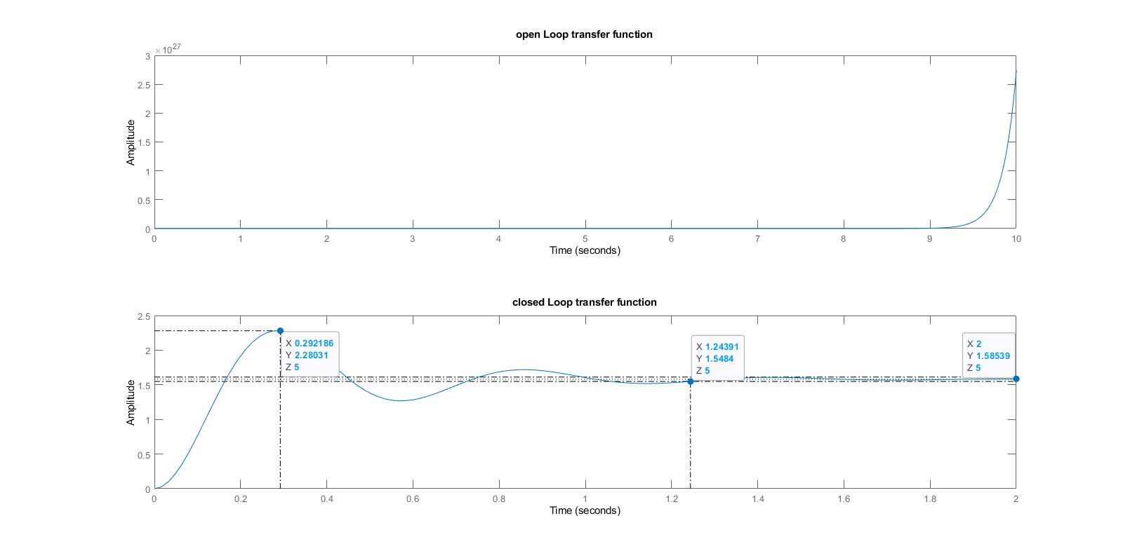

Q2)

**Matlab Code :**

%Soal 2 Tamrin 2

%HamedBaghestani (40116143)

clc;

clear all;

close all;

s=tf('s');

LS=0.4/(s+0.4);

TS=0.4/(s+0.8);

figure('Name','Soal2','NumberTitle','off');

hold on;

step(LS,25);

step(TS,25);

legend;

stepinfo(LS)

stepinfo(TS)

damp(LS)

damp(TS)

**Output or Plot :**

Datas of Open Loop System (Ls) :

RiseTime: 5.4925

TransientTime: 9.7802

SettlingTime: 9.7802

SettlingMin: 0.9045

SettlingMax: 1.0000

Overshoot: 0

Undershoot: 0

Peak: 1.0000

PeakTime: 26.3646

|  |  |  |  |
| --- | --- | --- | --- |
| Pole | £ | Frequency | Time Constant |
| -4.00e-01 | 1.00e+00 | 4.00e-01 | 2.50e+00 |

Datas of Closed Loop System (Ts) :

RiseTime: 2.7463

TransientTime: 4.8901

SettlingTime: 4.8901

SettlingMin: 0.4523

SettlingMax: 0.5000

Overshoot: 0

Undershoot: 0

Peak: 0.5000

PeakTime: 13.1823

|  |  |  |  |
| --- | --- | --- | --- |
| Pole | £ | Frequency | Time Constant |
| -8.00e-01 | 1.00e+00 | 8.00e-01 | 1.25e+00 |

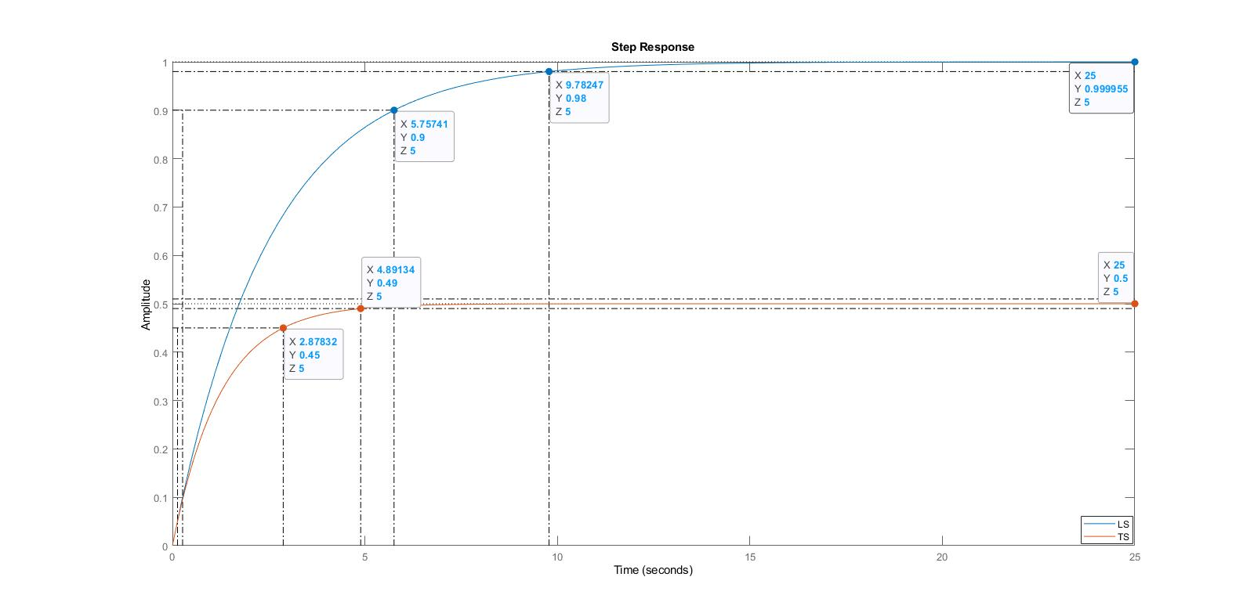

Q3)

**Matlab Code :**

%Soal 3 Tamrin 2

%HamedBaghestani (40116143)

clc;

clear all;

close all;

s=tf('s');

Ts=8/(s^2+4*s+8);

Ts

figure('Name','Soal3','NumberTitle','off');

step(Ts);

**Outpot or Plot :**

Ts =

8

-------------

s^2 + 4 s + 8

* 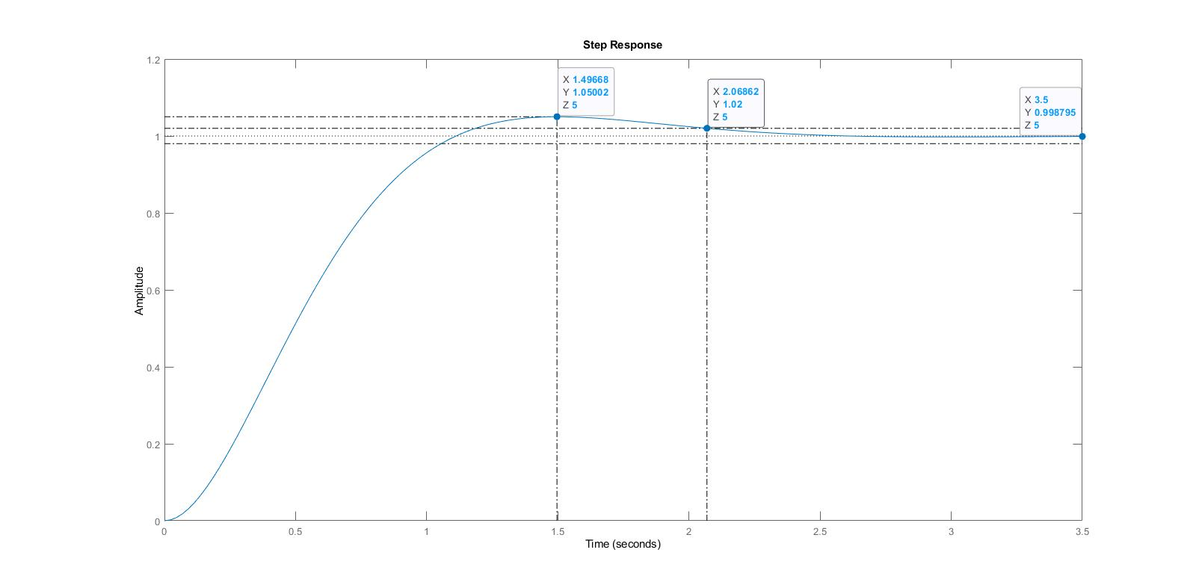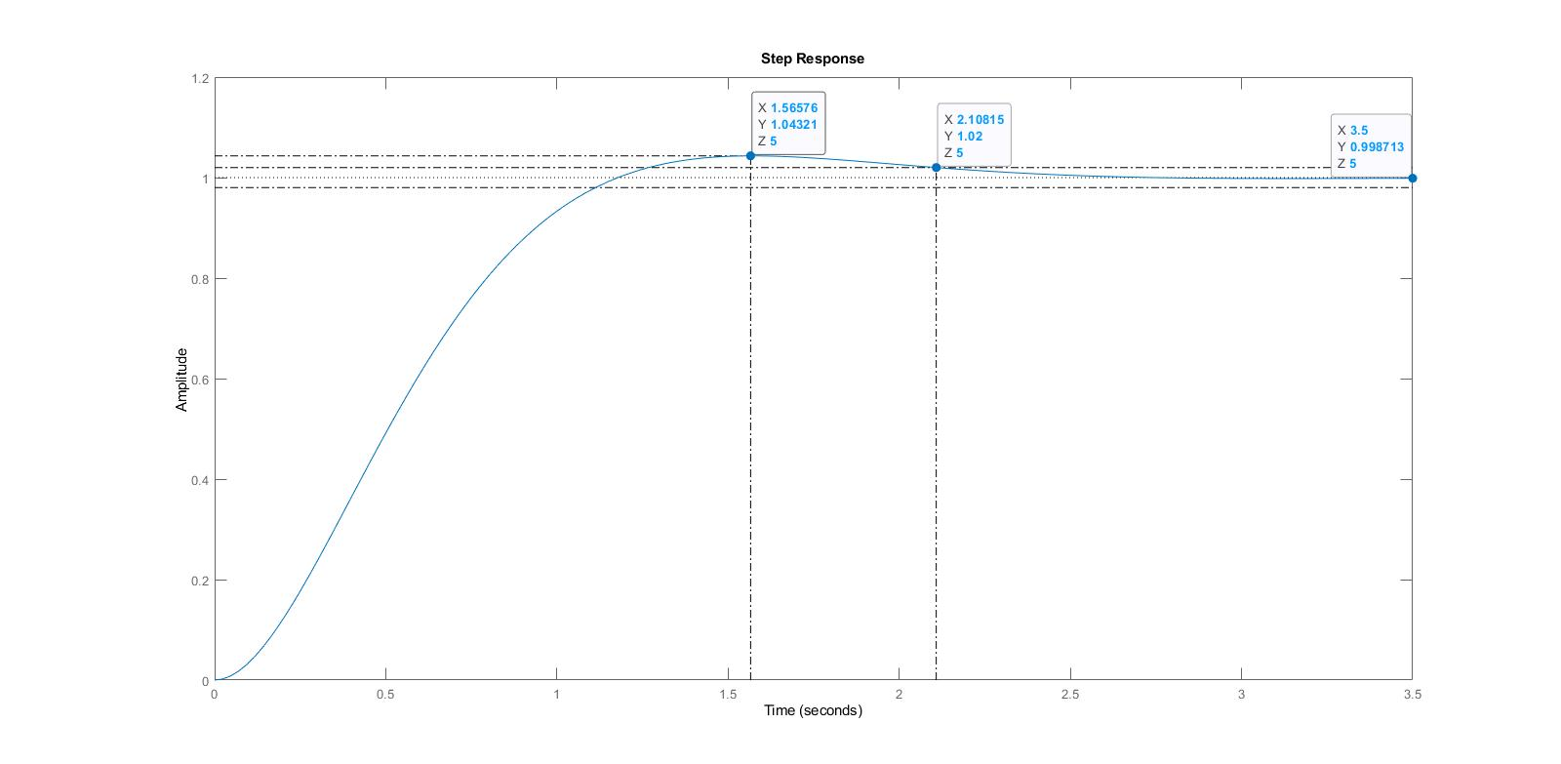As we discussed in the handwritten solution, if we want to have an exact answer according to what the question asked; we should equate K with 8.4 . then we have below plot :